**CS6106 - Database Management Systems**

**Project**

**SupplyX**

[Documentation]

**Bava Viknesh R M G** **Saikumarran S K** **Sujith Vishal V**

2020103514 2020103561 2020103572

**INDEX**

**ABSTRACT 3**

**INTRODUCTION 4**

**ER DIAGRAM 8**

**DATABASE DESCRIPTION 9**

**DEVELOPMENT ENVIRONMENT 11**

**IMPLEMENTATION 11**

**FUTURE SCOPE 21**

**CONCLUSION 21**

**REFERENCES 21**

**ABSTRACT**

There are often instances in real life where manufacturers need to open warehouses in multiple locations to meet faster and easier delivery of products. To open a warehouse of its own has its own logistics and expense issue. So, manufacturers go for 3rd party companies who offer warehouses of their own. This leads to the stocking up of manufacturers’ products in multiple locations at cheaper rates. These companies also provide transportation of ordered products, as some products might not be available at all locations and need to be transported only when needed.

If the manufacturers had their own warehouses and had to transport some products from one location to another, there might arise a situation where the stocks are less and the space that could be accommodated by the transport vehicle is empty at large. This leads to a waste of fuel and time. The 3rd party companies could collate the stocks of all the contracted manufacturers and assign them a single vehicle for transport, which leads to efficient use of fuel and time. The 3rd party companies need to have a dedicated supply chain management system to avoid discrepancies among the various manufacturers and their products and also maximize their transport path efficiency as required.

**INTRODUCTION**

Supply chain management is an important concept, which is primarily the backbone of how modern businesses work. Accounting is important, so as to track changes and make adjustments to accommodate future upscaling or downscaling. The way the supply chain is managed directly affects the business decisions as it highly influences the profits made and losses occurred.

One important part of supply chain management is the on-demand movement of stocks from production warehouses to consumer warehouses. The regular stocking up is necessary to meet the market demands. Some products don’t fluctuate, so the required stocking up pattern can be a periodical and predictable one, though there are other products whose market demand fluctuates in short term cycles. No matter what the type of products that need to be stocked is, an efficient way to manage this on-demand stocking requests and subsequent servicing is really necessary.

Another issue that arises is the need for setting up and maintenance of warehouses at all the target market locations by the manufacturers. This is not possible for all types of manufacturers. Some might be interested in upscaling but due to capital and maintenance overhead required for starting up a warehouse at a new market area is not possible.

And yet another issue that comes up is the stock movement itself. An ordinary manufacturer, provided he has set up warehouses at different location as per market needs. But now they have to see to the regular movement of stocks from production location to the market areas. This movement may be non-uniform, as some locations might have potential for more selling as compared to others. Also, the manufacturers need to have a vehicle force to accommodate the stocking requests. Now, not all locations would demand equal stocks and also the vehicle for each transit may not completely utilize its space. This leads to wastage of fuel, space, time and it leads to increase in pricing of products in market to compensate for the transport overhead.

To tackle these kinds of obstacles, 3rd party firms emerge. They provide storage and transit as a service. Multiple manufacturers enter into contract with them, and they stock up their products in warehouses owned by these 3rd party companies. The 3rd party companies follow a rental model. This leads to significant cut down in capital investment for the manufacturers, as they need not invest in opening, setting up and maintenance of a warehouse at different locations.

As for transit, requests from multiple manufacturers are grouped together as per common transit route. This leads to efficient usage of fuel and space. This too in turn contributes to reduction in pricing of products for the end consumer.

Now, these 3rd party companies in turn need to have a dedicated management system software to take care of the various manufacturers’ stock movement requests and as well to track its execution. They need to hire a dedicated developer team for developing a tailor-made system software to manage its operations.

Here comes SupplyX. We provide an out-of-the-box solution to those 3rd party supply chain management companies, involving all the typical features so as to provide an easy way to manage its operations. We also are one of those 3rd party company, which provides a Storage-and-Transit-as-a-Service (SaTaaS) to every kind of manufacturer out there.

**Advantages :**

* No need to develop tailor-made supply chain management system software for the 3rd party companies, as we provide a custom out-of-the-box solution.
* Efficient usage of fuel and space for transporting various manufacturers’ stocks by collating orders having common source and destination together.
* Rental model of warehouses leads to less capital overhead and therefore leads to reduction in product pricing for consumers.

**Working Description :**

The user logins/signups to the app via the user side interface. The user lands on the user dashboard. There are four options available to the user, namely – Your Orders, New Order, Order History, Track Order.

In Your Orders, the orders which were placed by the user shows up and which are either ‘pending’ or ‘approved’, but not ‘delivered’ nor ‘rejected’, are displayed in accordions, on clicking which the order details are displayed in a table format. In New Order, the user can fill in the details of a new order, namely – Source, Destination, Weight, Product Description and on getting the quote of the order, can place the order.

In Order History, the orders which are either delivered or rejected are displayed in accordions. Further details are shown in a table format on clicking each accordion. In Track Order, the order ID of the desired order is entered. The details of the order such as current hub and other details are shown in a table format.

On the admin side, the admin enters the app via a hidden route and signs in with a pre-assigned credentials. The admin lands on the admin dashboard then. There are three options available to the admin, namely – Pending Orders, Update Status, Order History.

In Pending Orders, the admin can see the details of the pending orders, which were requested to the warehouse of which the admin is in-charge of. The admin can either allocate an available vehicle to the specific order and then approve it, or reject it.

In Update Status, the admin can enter the order ID of the order which has reached the warehouse in his control en route to the destination to update the current hub of the order. When the current hub matches destination, the status of the order finally becomes ‘delivered’. In Order History, the admin can see the orders given to the warehouse in his control, which had been either ‘rejected’ or ‘delivered’.

**ER DIAGRAM**

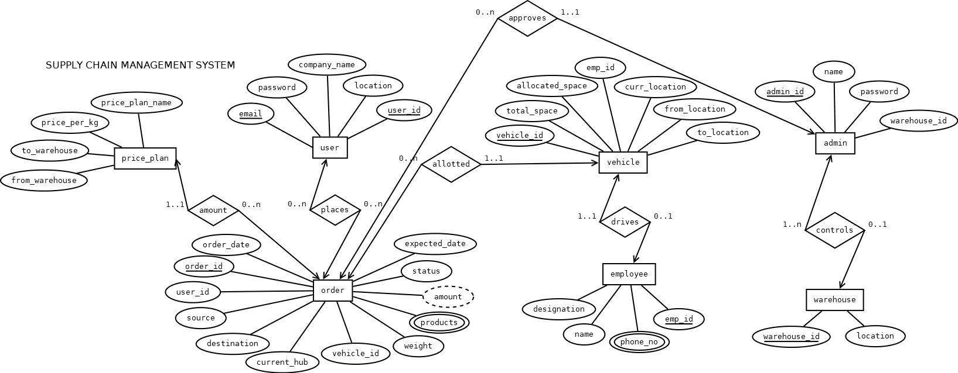

**DATABASE DESCRIPTION**

Database (RDBMS):

MySQL, MySQLWorkbench

**Tables and Attributes :**

|  |  |
| --- | --- |
| **Table Name** | **Attributes** |
| Admins | Admin_id (primary key)  Name  Password  Warehouse_id (foreign key) |
| Users | User_id (primary key)  Email  Password  Company_name  Location |
| Orders | Order_id (primary key)  Order_date  User_id (foreign key)  Source (foreign key)  Destination (foreign key)  Current_hub (foreign key)  Vehicle_id (foreign key)  Weight  Products  Amount  Status  Expected_date |
| Warehouses | Warehouse_id (primary key)  Location |
| Price_plans | From_warehouse (foreign key)  To_warehouse (foreign key)  Price_per_kg  Price_plan_name |
| Vehicles | Vehicle_id (primary key)  Total_space  Allocated_space  Emp_id (foreign key)  Curr_location (foreign key)  From_location (foreign key)  To_location (foreign key) |
| Employees | Emp_id (primary key)  Name  Designation  Phone_no |

**Relationships :**

|  |  |
| --- | --- |
| **Relationship name** | **Table name** |
| Places | Users to Orders |
| Allotted | Orders to Vehicles |
| Controls | Admins to Warehouses |
| Approves | Admins to Orders |
| Amount | Price_plans to Orders |

**DEVELOPMENT ENVIRONMENT**

**Frontend**: ReactJS, MaterialUI

**Backend**: NodeJS

**Database**: MySQL

**IMPLEMENTATION**

**Working Flowchart :**

**User Side :**

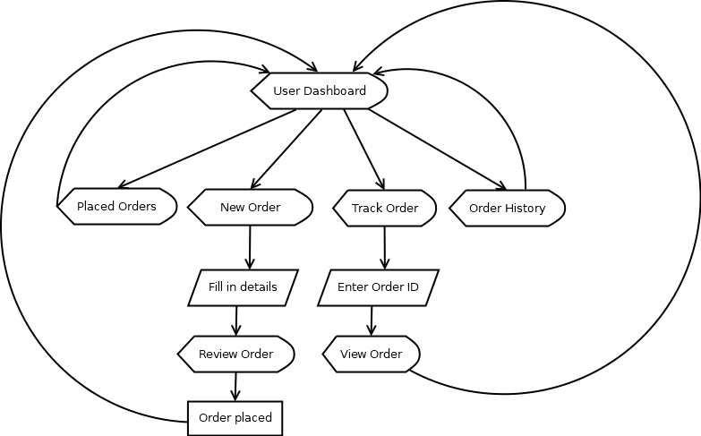

**Admin Side :**

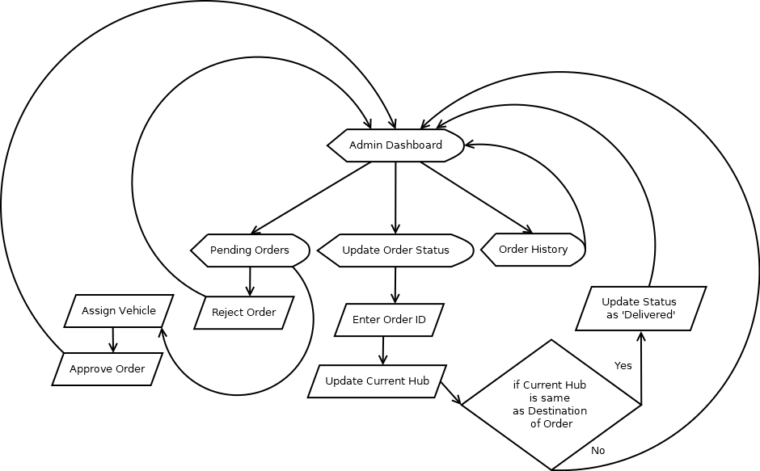

**Working Screenshots :**

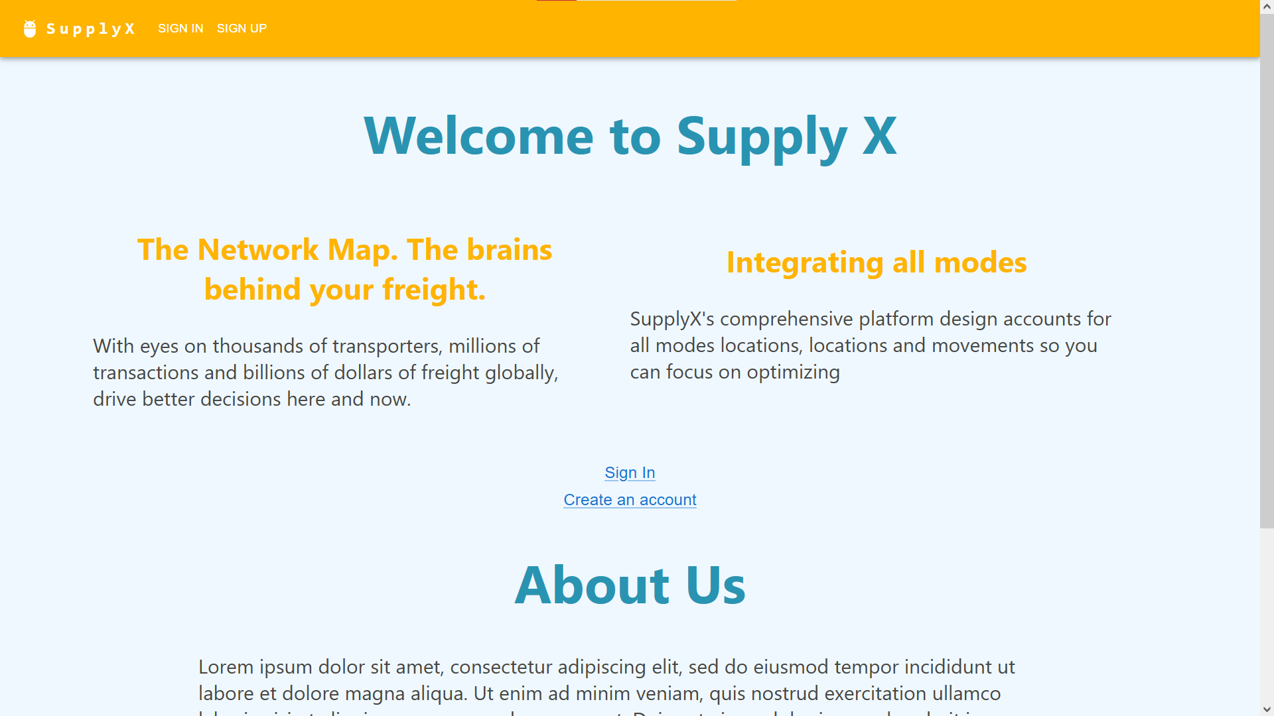

**Fig 1. Homepage of SupplyX**

The Homepage shows info about the company. It also provides Sign-In and Sign-Up routes, as shown in Fig 1.

**User Side :**

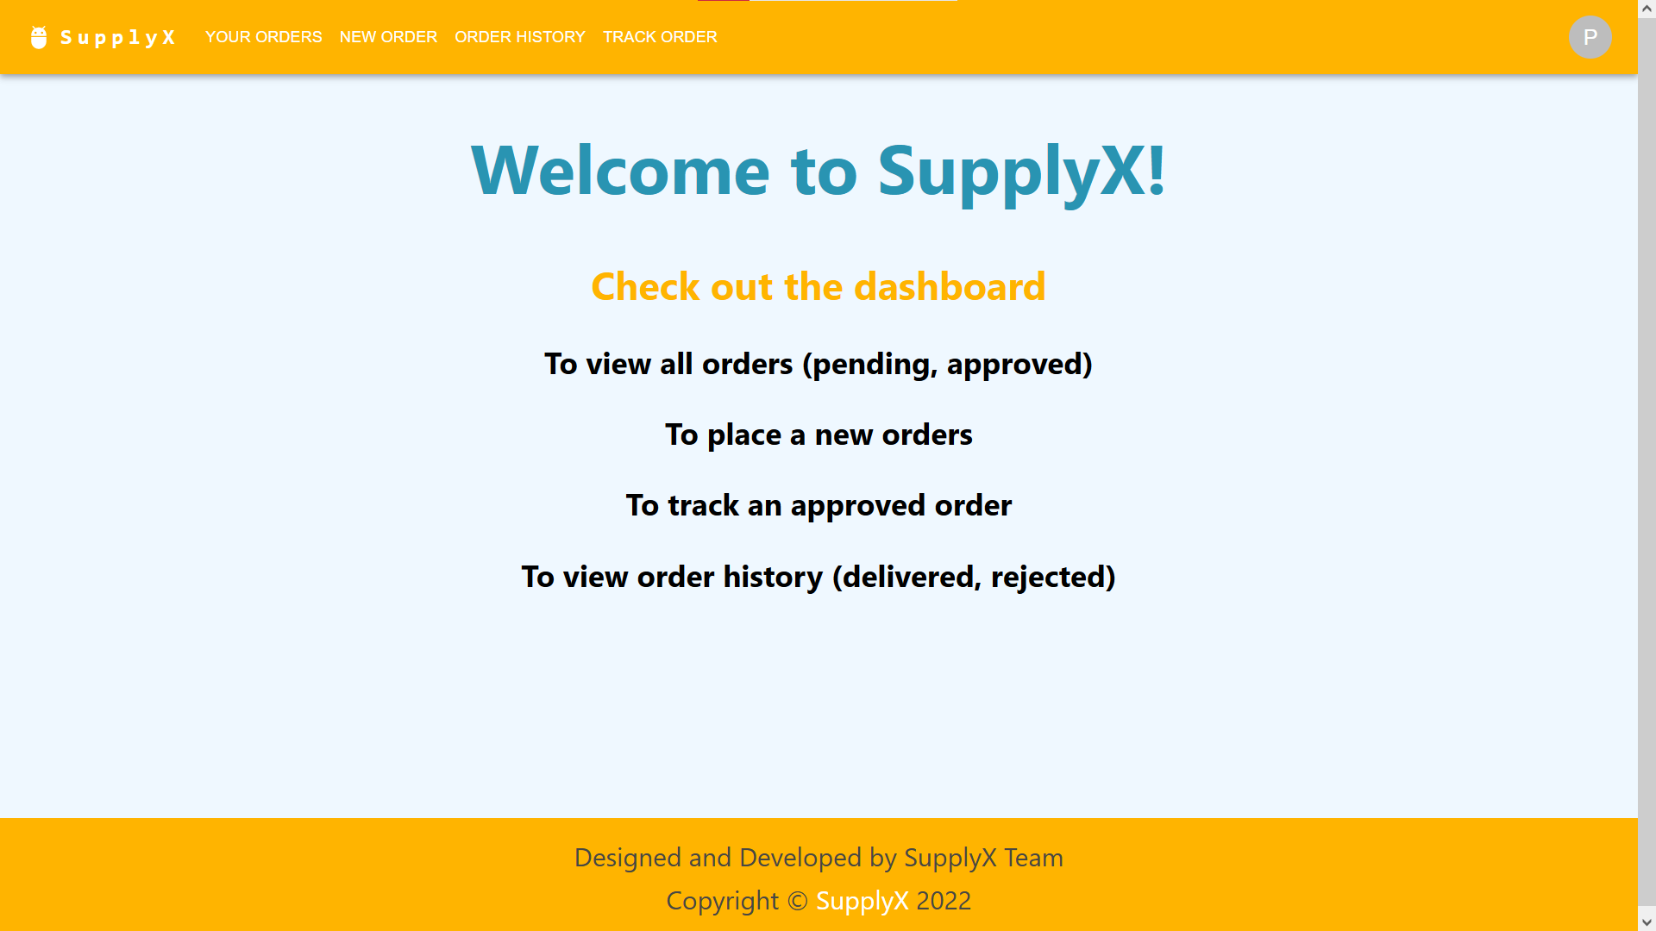

**Fig 2. Homepage of User Dashboard**

On successful sign-in/signup, the user lands on the homepage of his dashboard, as shown in Fig 2.a.

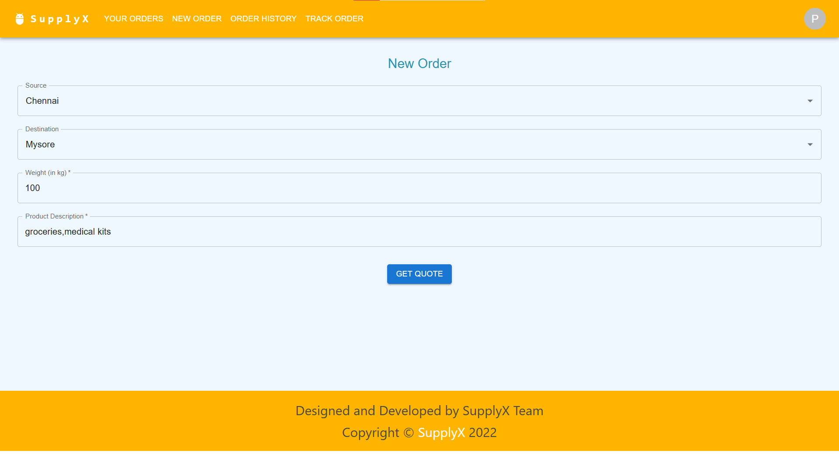

**Fig 3.a. New Order (Get Quote)**

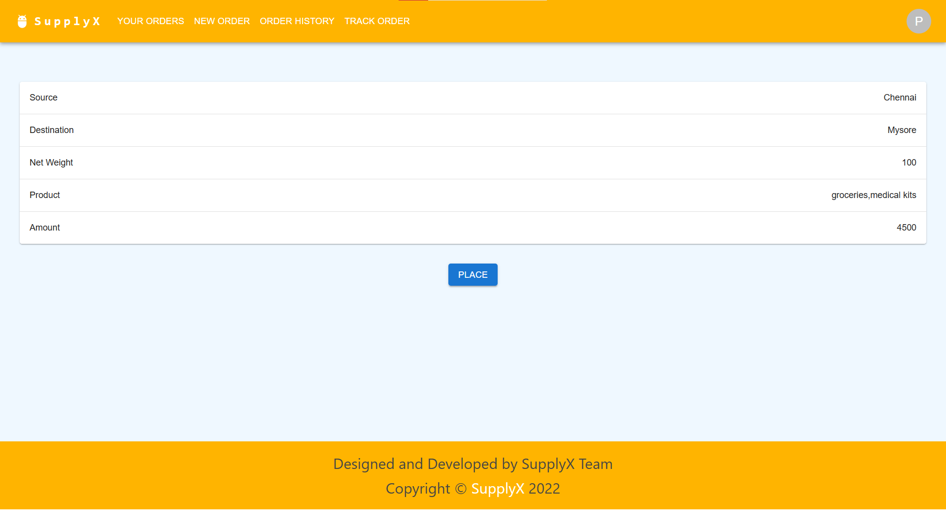**Fig 3.b. New Order (Place Order)**

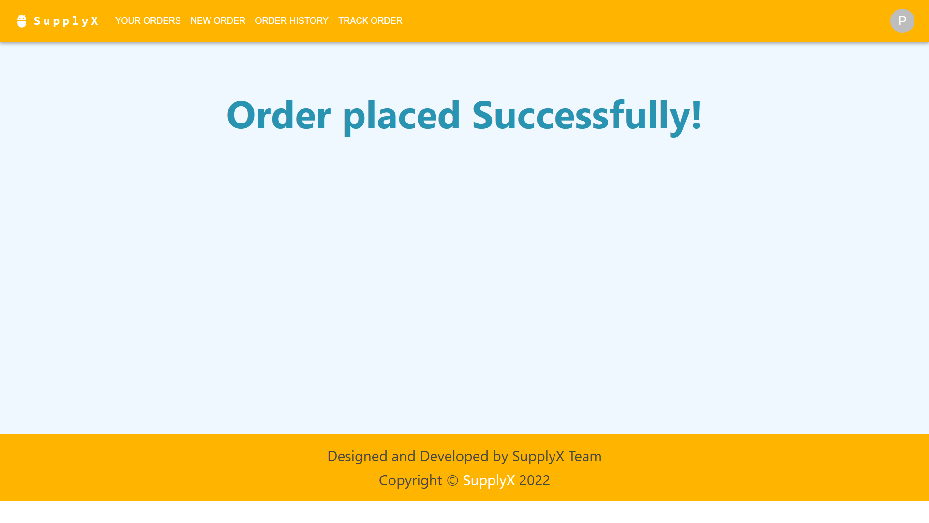

**Fig 3.c. New Order (Success Message)**

The details of the order to be made are filled in (refer Fig 3.a.) Then, on review of order specifications such as amount, the user can then place order, as shown in Fig 3.b., on which success message is shown (refer Fig 3.c.)

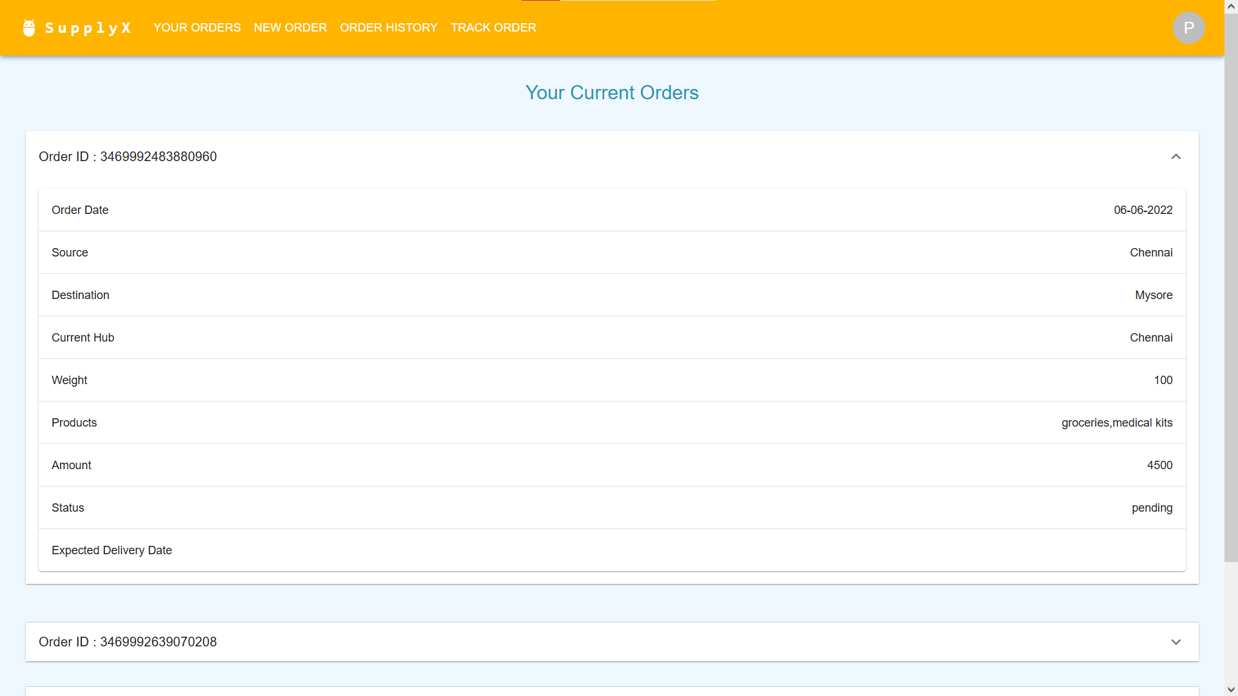

**Fig 4. Your Orders (Current)**

The orders placed by the user, which are either pending or approved, are displayed, as shown in Fig 4.

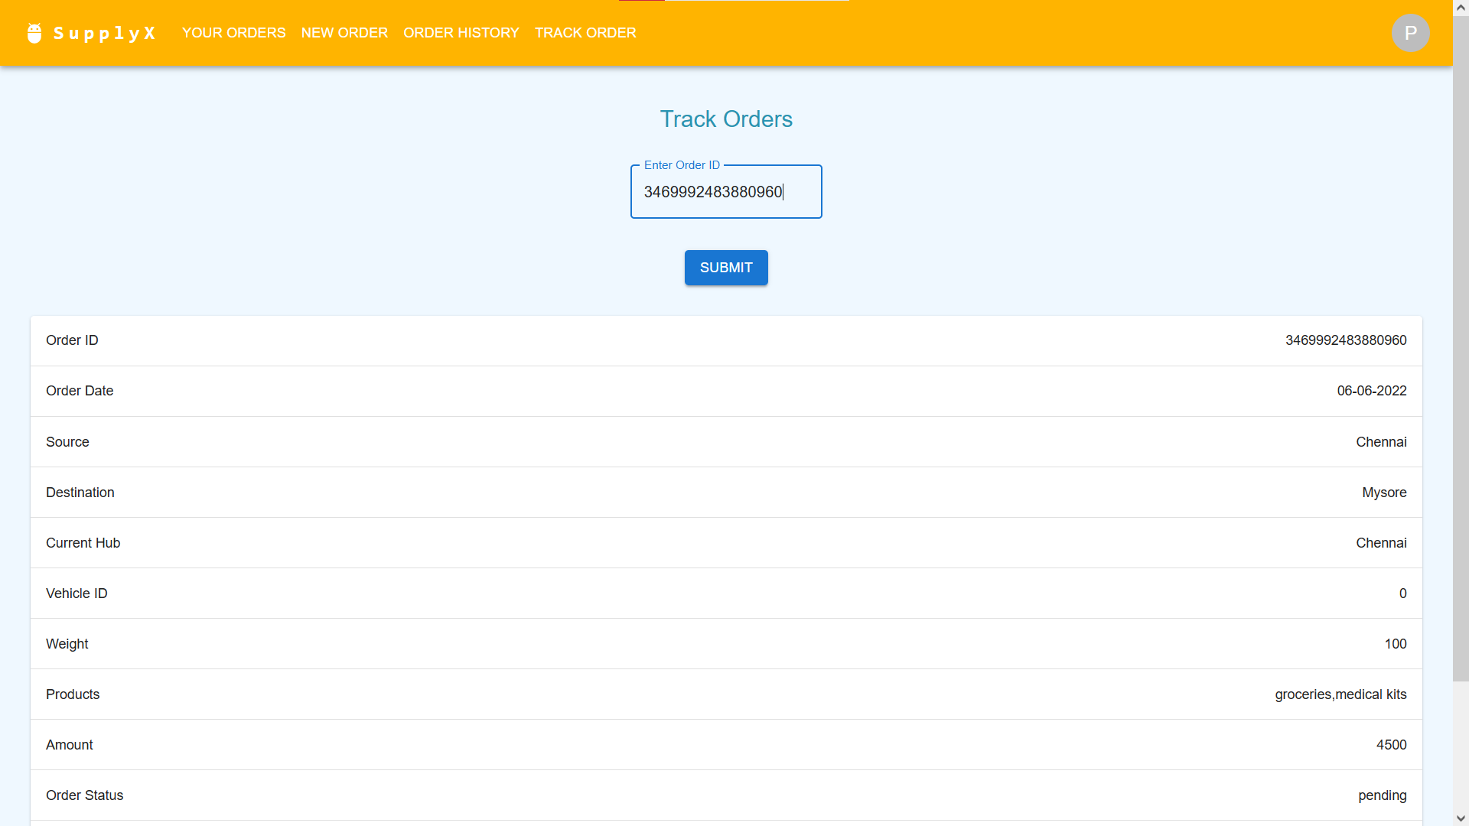

**Fig 5. Track Order**

The user can track the order of his choice, by entering in the order ID (Refer Fig 5.) Details such as Current Hub and others are shown.

**Admin Side :**

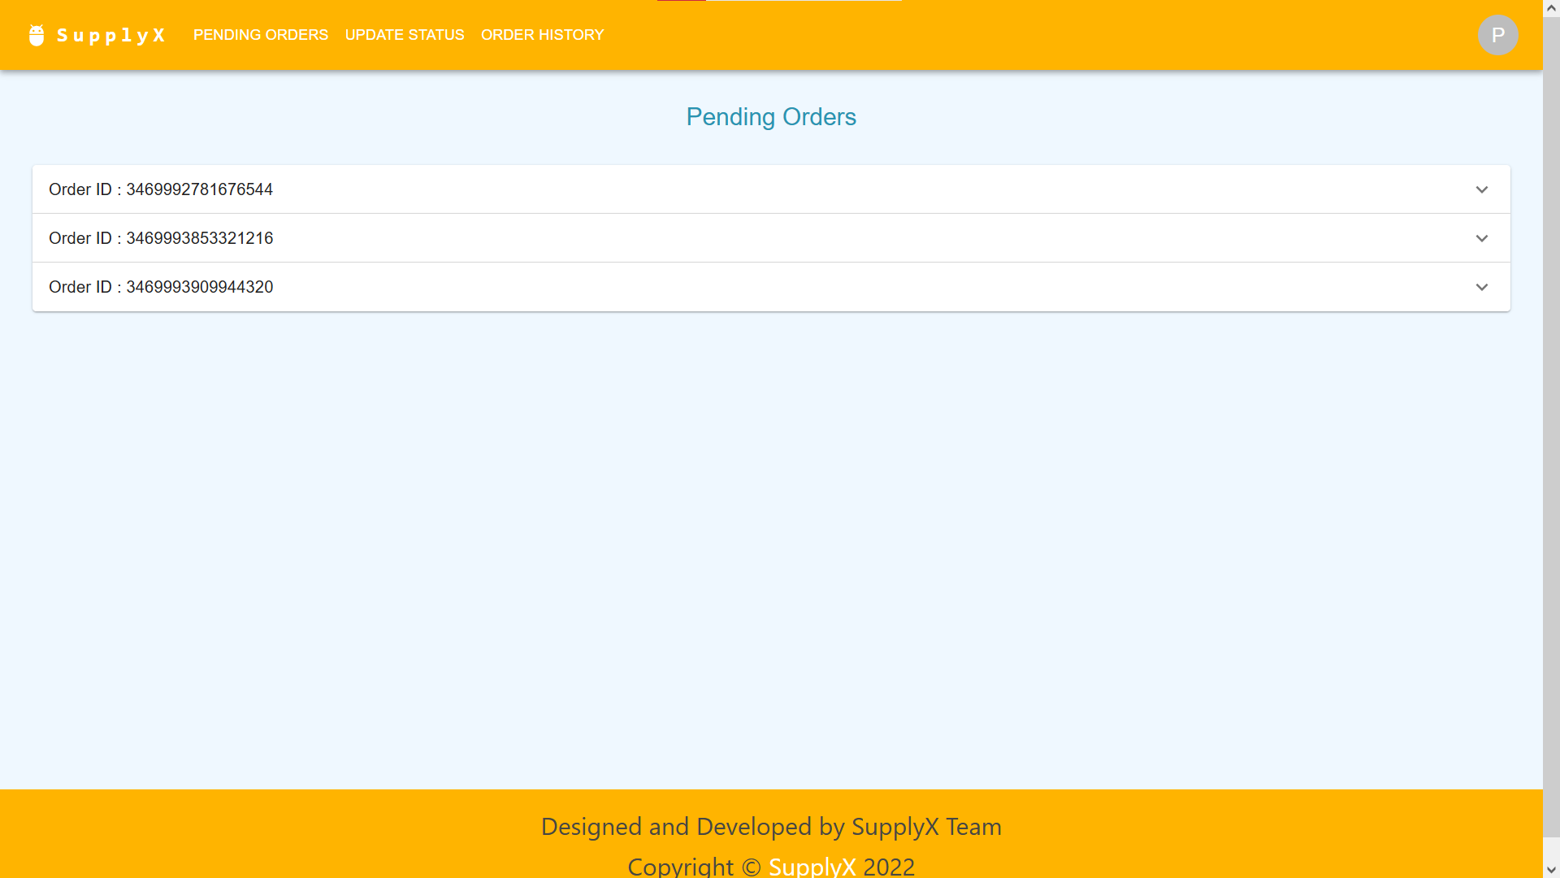

**Fig 6.a. Pending Orders (Display Orders)**

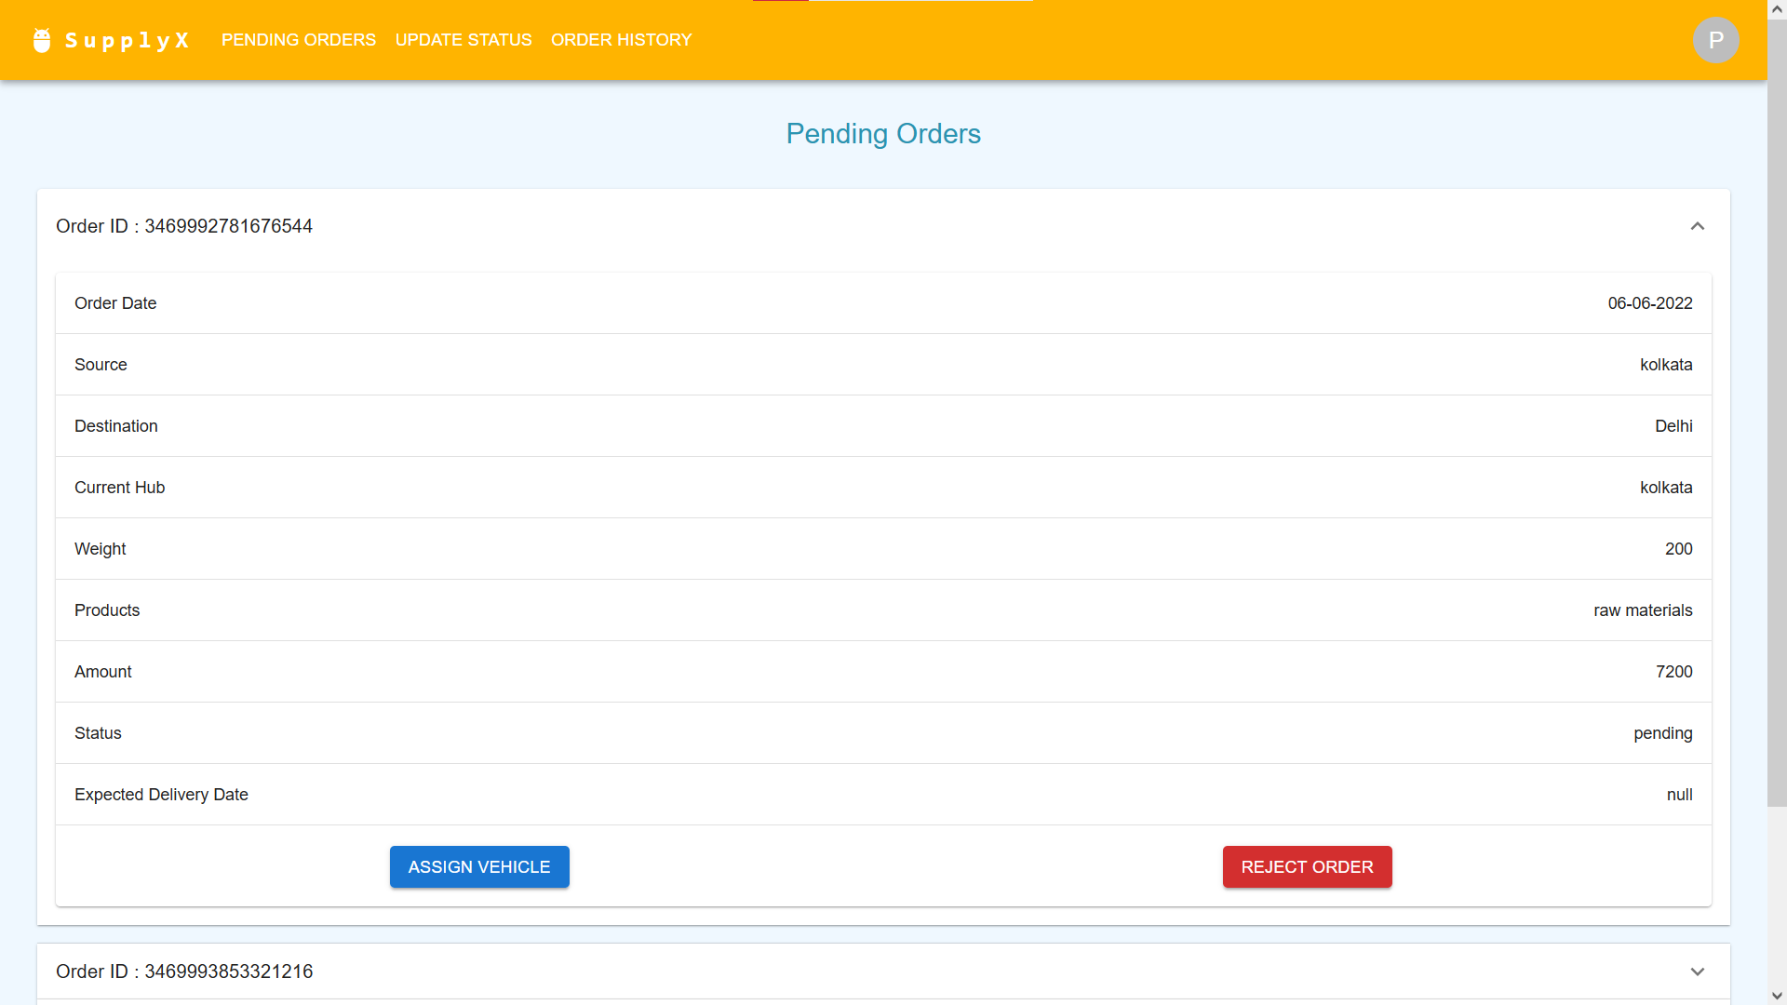

**Fig 6.b. Pending Orders (View Each Order)**

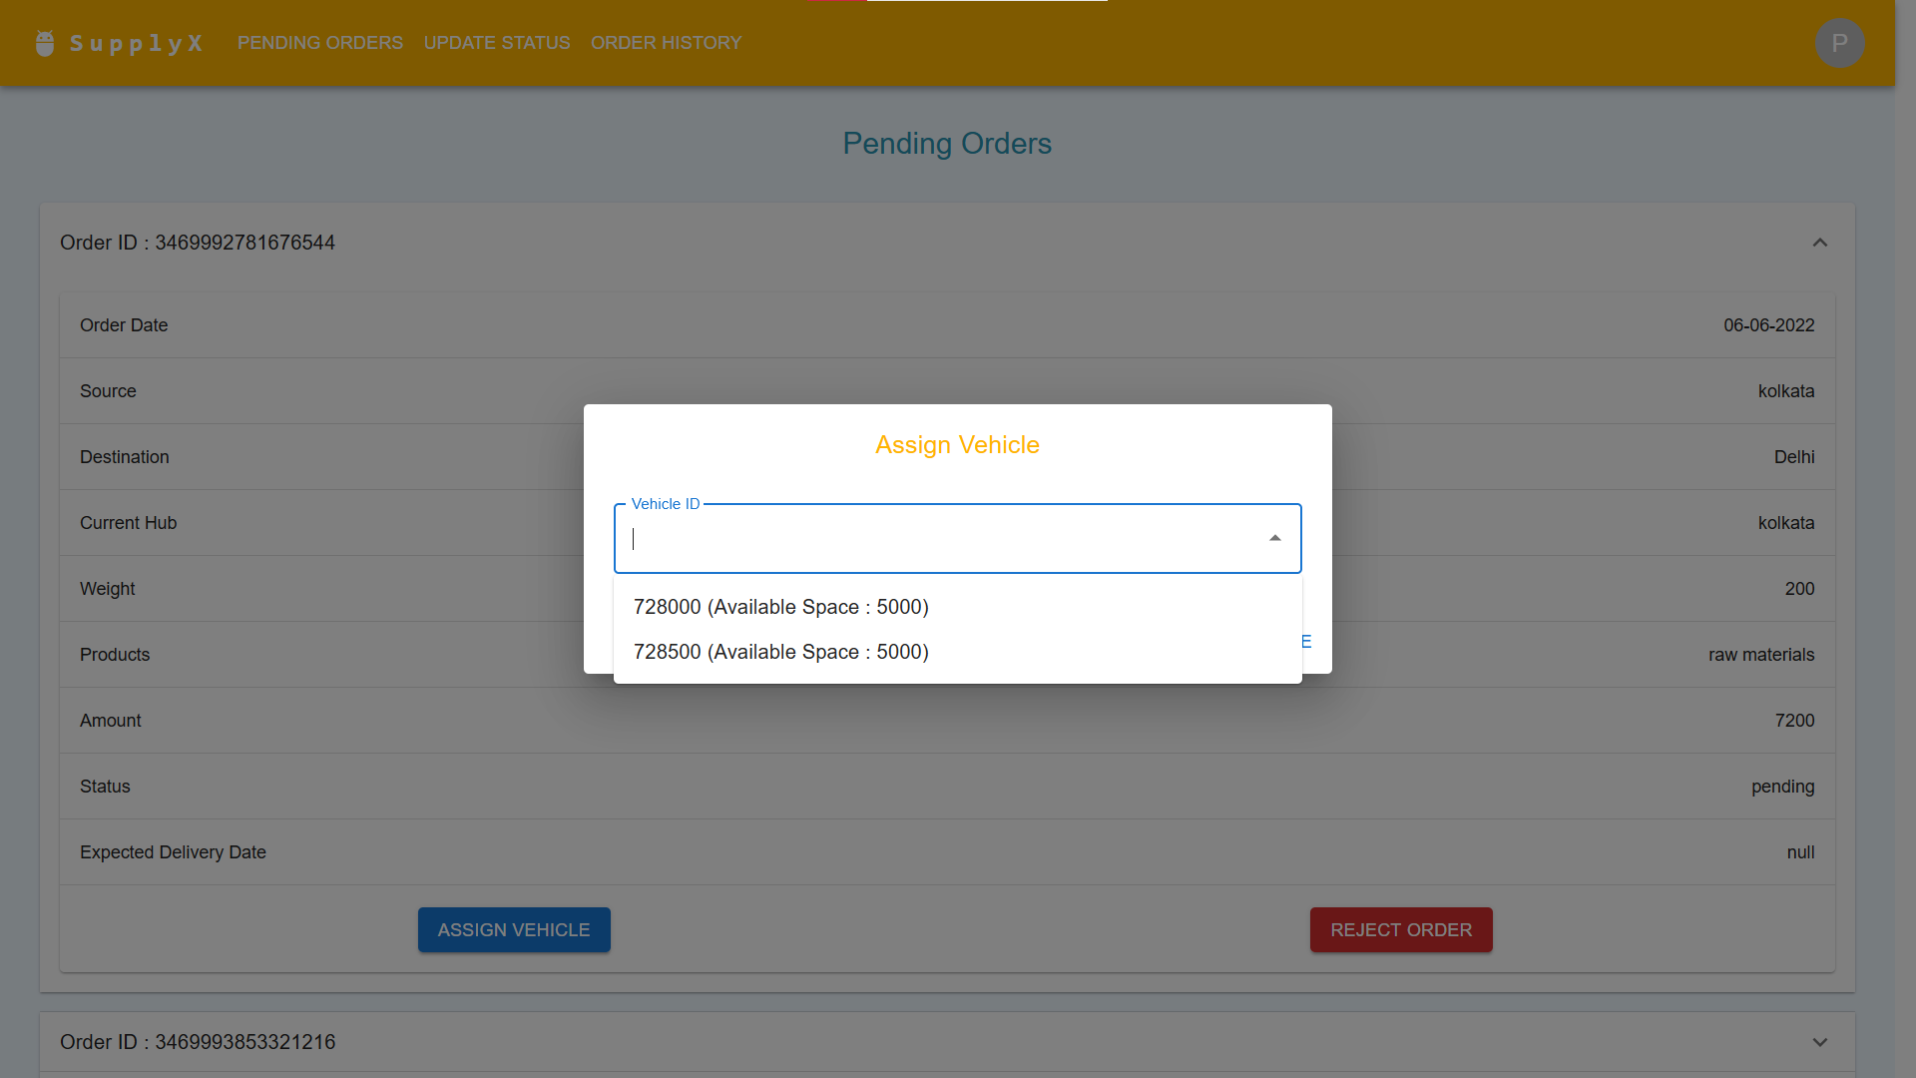

**Fig 6.c. Pending Orders (Assign Vehicle)**

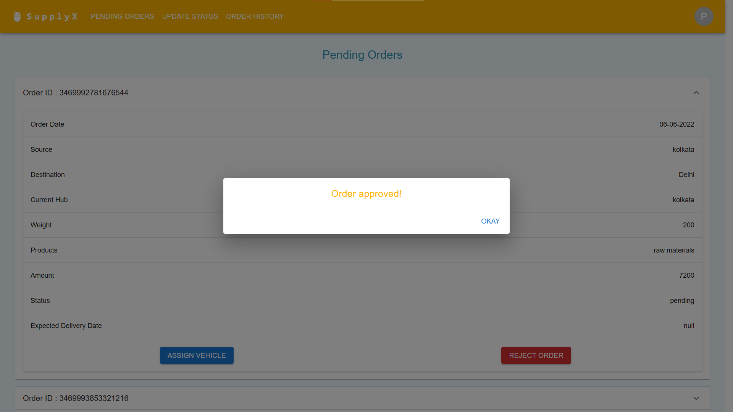

**Fig 6.d. Pending Orders (Approved Message)**

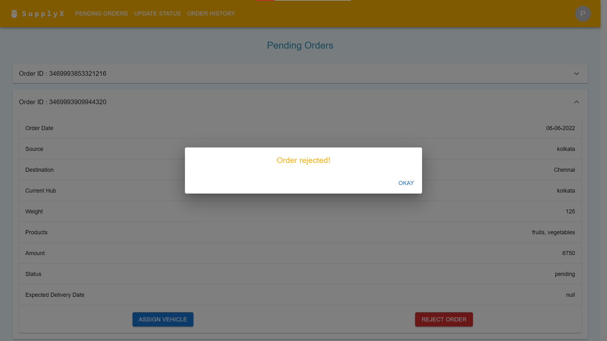

**Fig 6.e. Pending Orders (Rejected Message)**

The orders which have been requested from the warehouse of which the admin is in-charge of, and have not yet been either approved or rejected, are displayed, as shown in Fig 6.a. The admin can then select any order (refer Fig 6.b.) and then either Assign Vehicle (Fig 6.c.) or Reject Order (Fig 6.e.) A Dialog Box pops up and the admin has to select a vehicle and then approve it, on which approved message appears, as shown in Fig 6.d.

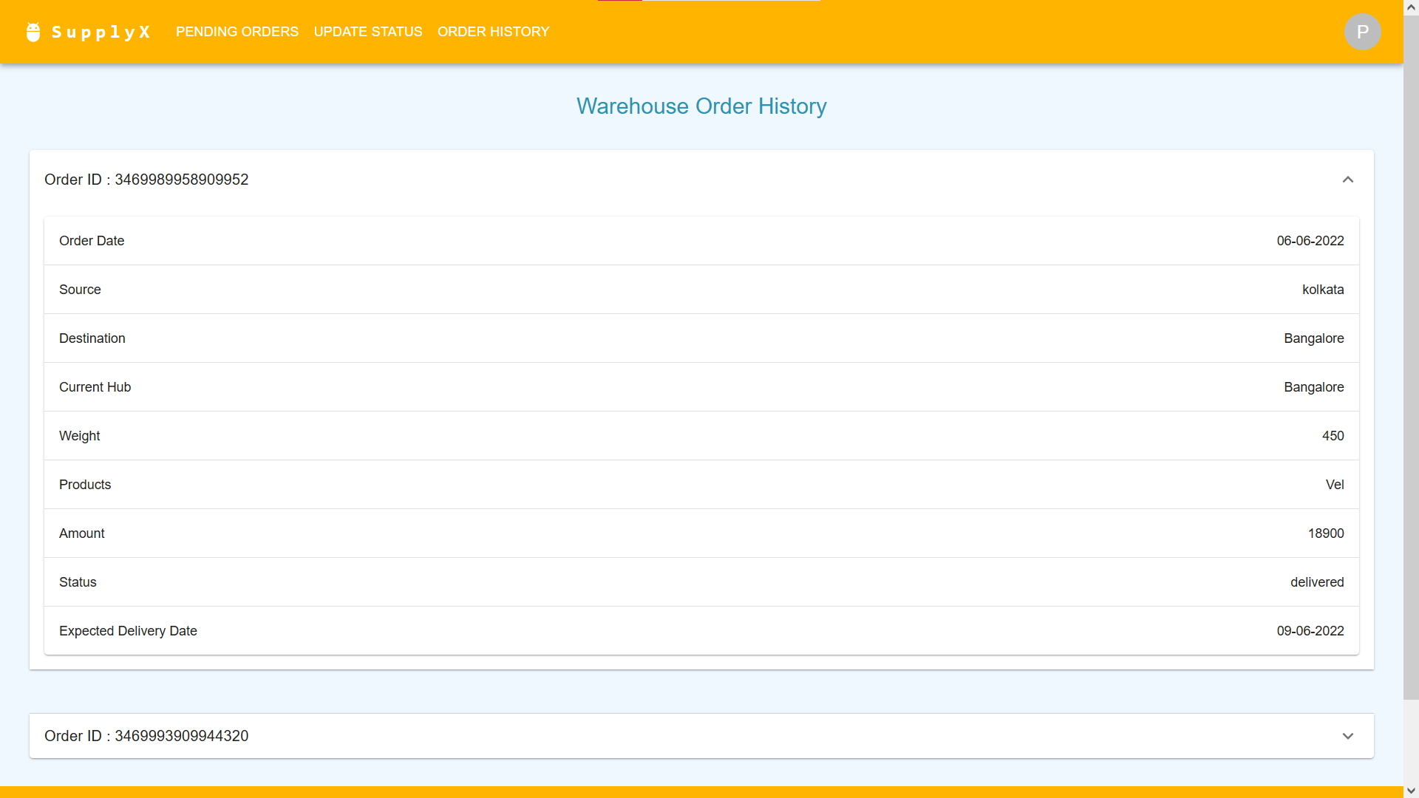

**Fig 7. Order History**

All the orders which have been placed to the warehouse and have either been delivered or rejected are shown (Refer Fig 7.)

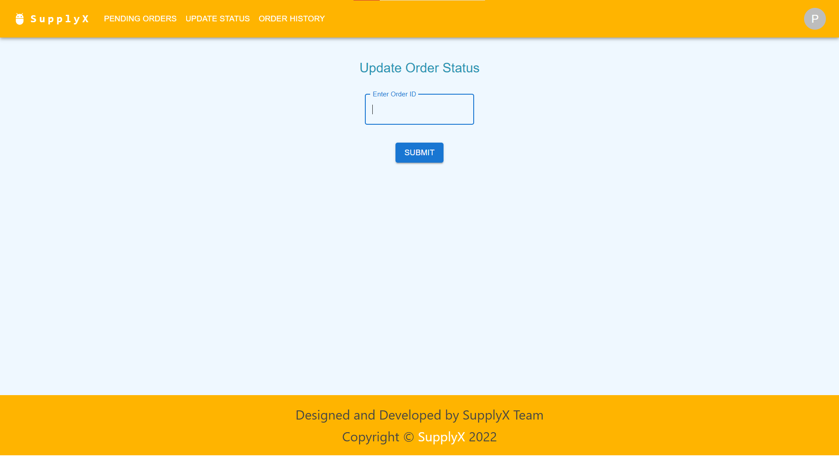

**Fig 8.a. Update Status (Enter ID)**

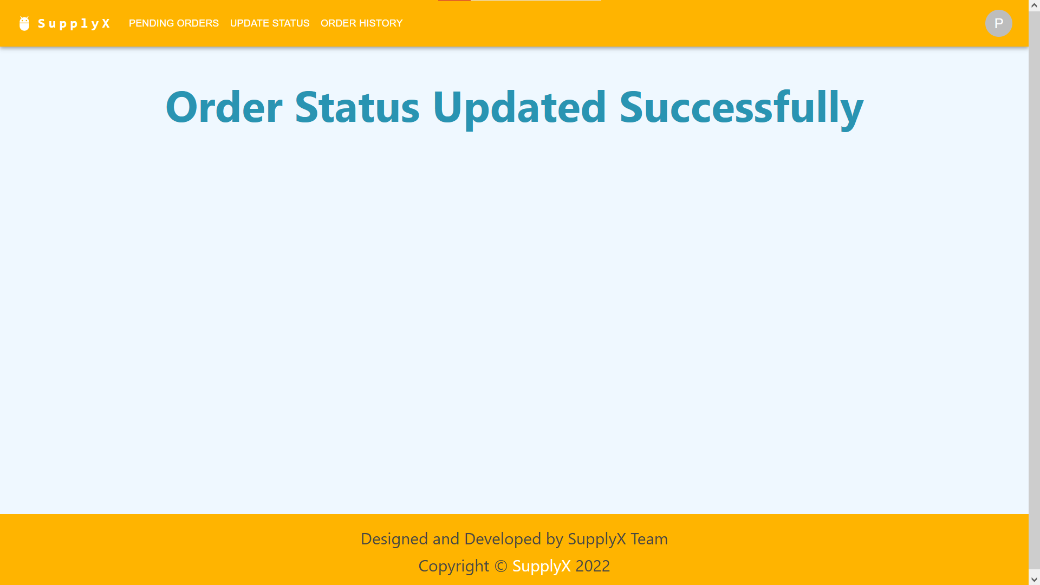

**Fig 8.b. Update Status (Success Message)**

The admin can update the status of those orders which have reached the warehouse, by entering the order ID, as shown in Fig 8.a., after which success message appears (Fig 8.b)

**FUTURE SCOPE**

The work done by the admin should actually be automated in a real-life large-scale operative. The employee details should be maintained for extended support and mishap handling. Live tracking feature could be added. With the right funding and vision, this could lead to an actual start-up, which would lead to tie up with major everyday brands. The management system software could be released as a product tapping on the supply chain management market.

**CONCLUSION**

We have provided a solution to the expenses related to the transport and storage overhead related to supply chain management in the form of rental contracts offered by 3rd party companies. We provide SaaS (Software-as-a-Service) to accommodate the needs of such 3rd party companies. We cater to them by providing them with an out-of-the-box solution, with all their typical execution and administration needs taken care of. By subscribing to our product, they avoid the need for a dedicated tech team to develop and debug a tailor-made management system software.

**REFERENCES:**

**ReactJS :** <https://reactjs.org/>

**MaterialUI :** <https://mui.com/material-ui/>

**NodeJS :** <https://nodejs.org/en/docs/>

**MySQL :** <https://dev.mysql.com/doc/>